Changing the Narrataive
Presented by – Dr. Lisa Patierne

We are all born storytellers. We create and use narratives all the time. In fact, our own inner voice remains our most influential storyteller. Psychology tells us that if there isn’t a narrative or story to offer, the mind will make one up. Add to that mix, stories others tell about us. In today‘s world where police officers are constantly under scrutiny and the focus is on stories that highlight the negative, it is more important than ever to focus on “changing the narrative.” Mahatma Gandhi said, “You can't change how people treat you or what they say about you. All you can do is change how you react to it.” Learn how to navigate the narrative in order to create a new blueprint, a new vision and a new response that is transformational.

About Dr. Lisa Patierne
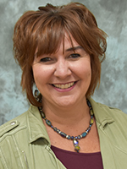
Dr. Lisa Patierne is a dynamic motivational speaker, author, success trainer, and coach, drawing upon her 29 years as an educator, leader, and high school principal. She has combined her experience, training, and research to deliver unforgettable experiential keynote presentations and workshops that assists organizations, teams, and individuals in reaching their greatest potential.
Lisa holds her doctorate in Educational Leadership from Sage College of Albany; formal certification in both the Success Principles®; and as a Barrett Values Centre Consultant and is a Regenerating Images in Memory (RIM) ® facilitator.
Lisa is a #1 International Best Selling author with her book Women Who Shine and is currently co-authoring another book entitled RESPONSIVE Leadership with Lieutenant Colonel (US Army Retired) John Nawoichyk (Associate Athletic Director, United States Military Academy at West Point), which is designed to help individuals, teams, and organizations discover how to build confidence, increase resilience, live with passion and purpose, and accomplish every goal they set, no matter who they are or where they came from.
As the educational consultant for the State of New York Police Juvenile Officers Association, Dr. Patierne has provided training to nearly a thousand police officers using the concepts of RESPONSIVE Leadership, in order to build resilience, strengthen leadership, and understand and minimize the effects of trauma on police officers, their families, and the communities they serve, which will ultimately create bridges of peace, hope, trust, and success for all.

Leadership Summit
Presented by – Rear Admiral June Ryan and Dr Lisa Patierne

We live within a worldwide ecosystem of economics, climate, people, and so much more; all interdependent upon one another. As leadership and psychology continue to evolve, we are learning more and more and gaining new insights and understandings of how these systems impact our effectiveness as a leader. Learn how you can become the “positive node” in your workplace, your family, or your community. Learn how you can help those around you improve their creativity, their productivity, their abilities, their performance and more. In doing so, you will not only help the group become better, but you are also exponentially increasing your own potential for success

About Rear Admiral June Ryan
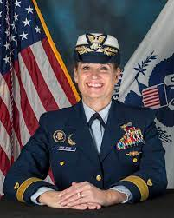
Rear Admiral June Ryan is a motivational speaker, Success Trainer and coach drawing upon her 35 years of military service, three formal certifications in the Success Principles - Getting from Where You Are to Where You Want To Be®, by Jack Canfield, co-Author of Chicken Soup for the Soul®, and certification as a Barrett Values Centre Consultant®. Along with other thought- leaders from around the world, she is also a contributing author to the Jack Canfield book “Breakthrough Success” that reached Best Seller status on Amazon.

During her career, Admiral Ryan was a trailblazer, achieving many historical firsts for women – including the first enlisted woman in the Coast Guard to rise to the rank of Rear Admiral, the first woman to serve as the Military Advisor to the Secretary of Homeland Security, and the third woman in our nation’s history to serve as the Military Aide to the President of the United States.
She served in a wide variety of leadership roles including five command positions; two aboard Coast Guard cutters, and three regional units ashore. Her personal military awards include the Coast Guard Distinguished Service Award, two Defense Superior Service Medals, three Legion of Merits, and six Coast Guard Meritorious Service Medals among many others. Rear Admiral Ryan holds a Bachelor of Science degree in Biology from Bowling Green State University, and a Master of Arts degree in Adult Education from the University of South Florida. She is an Adjunct Professor in Boler College of Business, John Carroll University, Masters in Business Administration (MBA) program assisting in the executive leadership and communications courses.

When not speaking or volunteering, she enjoys spending time with her husband of 35+ years,
their 20-year-old daughter, Aisling, and their dog Lucy.

Handle with Care
Presented by Maria Behier and Frank Guglieri

The “Handle with Care” program enables police to notify schools if they encounter a child at a traumatic scene, so schools and mental healthcare leaders can provide trauma-sensitive support right away.

About Maria Behier and Frank Guglieri
Marla Behler is a Licensed Master Social Worker in the State of New York who received her Master of Science Degree from Columbia University School of Social Work. She has worked in the field of Child Protection for over twenty-five years in a variety of settings including Jacobi Medical Center in Bronx, NY and the Victim Witness Assistance Program with the Santa Barbara District Attorney’s Office in California. Marla has held the position of Program Director at the Child Advocacy Center (CAC) of Putnam County since its opening in 1999. She works to ensure that children, suspected of being abused, receive coordinated services through a multidisciplinary approach. Under her leadership, the program has grown from one part-time position to a staff of ten serving close to 300 children per year. Expanding the mission to include prevention, Marla implements various public awareness campaigns and trainings promoting child safety and child abuse prevention issues. Marla also co-chairs the Putnam County Suicide Prevention Task Force and is a member of the Putnam/Northern Westchester BOCES Regional Suicide Safety in Schools Leadership Team and Regional Crisis Team.
Marla is an approved instructor of the New York State Child Abuse Identification and Reporting Course required by all licensed professionals involved in the reporting of child abuse and neglect. Marla was instrumental in bringing the “Protecting our Children, Lessons Learned from Sex Offenders” program to New York. She also assisted in the development of two New York State curriculums: “Less is More: A Trauma Informed Response for Professionals Mandated to Report Child Abuse,” and “First Responder: Understanding and Responding to Child Abuse Allegations.”

Frank Guglieri has been the Regional Safety Coordinator for Putnam | Northern Westchester BOCES for the past five years. He serves as a consultant, trainer, advisor, and inspector for 18 component school districts in the areas of security, safety, risk, and health in addition to 10 other non-component districts. Frank, a former chemistry and forensics teacher in the Wappingers Central School District, has extensive experience in writing and implementing emergency response plans, evaluating existing physical plants from a safety perspective, managing chemical storage and hygiene, managing waste disposal, developing safety procedures and policies, and conducting table-top and practical emergency drills. He is the regional trainer for schools on development and implementation of over 100 threat assessment teams and over 1,200 people throughout four counties. He is a trainer for Dr. Dewey Cornell in the Comprehensive Student Threat Assessment Guidelines. Frank functions as the BOCES COVID Coordinator and has trained over 50 COVID coordinators around the region. He is also the Coordinator of a Regional School Nurses Committee with 50 nurses. He Co-facilitates the Regional and Administrators Regional Crisis Team which provides professional development and crisis response to any school within the PNW BOCES region.
Frank holds a Bachelor's degree in chemistry and a Master's degree in special education from St. Mary's College, and has completed advanced study in forensics at the University of Florida and Syracuse University. He is currently working toward a Master's degree with the Future School Leaders Academy, Bank Street, Graduate School of Education.
Frank has said that his interest in safety was spurred by the Columbine incident, which occurred shortly before he began his teaching career. "As my job evolved, safety really developed into a passion of mine," he said.

Physical Education and Nutrition
Presented by Dr Mark Hamil

Keep ourselves fit and healthy is the ultimate goal of keeping a sound mind and help extent our life span. This course will discuss ways to keep ourselves healthy and fit at the same time of working in the police world.
Stop the Bleed
Presented by – Dr. Mark Hamil

Through our course, you’ll gain the ability to recognize life-threatening bleeding and intervene effectively. The person next to a bleeding victim may be the one who’s most likely to save him or her. Take the course and become empowered to make a life or death difference when a bleeding emergency occurs. Being educated in stopping the bleed help saves lives!

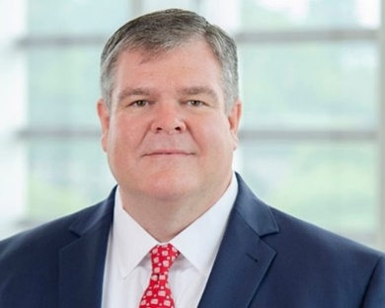
About Dr. Mark Hamil
Dr. Mark E. Hamill, MD, has been named the Police Surgeon of the SNYPJOA. Dr. Hamill is a former police officer for the Town of Clay, NY. He is now a Trama/Surgeon Critical Care doctor who is both Board Certified in general surgery and critical care.
Dr. Hamill completed his undergraduate degree in Biology at Long Island University – C.W Post campus and medical school at the State University of New York Upstate Medical University in Syracuse, New York. Following this he pursued residency training in General Surgery at the Medical University of South Carolina in Charleston and advanced training in Surgical Critical Care and Trauma Surgery at the University of Texas Southwestern Medical Center in Dallas. He has an extensive background in law enforcement and EMS including experience as a patrol officer with the New York City Police Department and the Town of Clay, New York and as both an EMT and Paramedic with the New York City EMS system, Rural Metro Medical Services and his local volunteer fire department. Currently he is a Trauma Surgeon and Surgical Intensivist at Carilion Roanoke Memorial Hospital, a level 1 trauma center located in southwestern Virginia. He is an Associate Professor at the Virginia Tech Carilion School of Medicine and has an active research program in trauma and critical care outcomes. He has lectured extensively on topics including firearms injuries, evaluation and treatment of victims of trauma, disaster management, surgical education, and critical care.
Kids Escaping Drugs : Adolescent Drug Trends for
Law Enforcement
Presented by John Bennet and Ashley Gedra
During this workshop attendees will learn current drug adolescent drug trends derived from focus groups conducted with adolescents from across the State of New York. In addition to current drug trends, attendees will also learn important details such current drug related clothing and concealment methods and how social media impacts substance use among adolescents. Attendees will also learn important skills to identify you who are struggling as well as how to connect them with assistance and resources. Additionally, treatment resources available to youth across all of New York will be discussed.
About John Bennet and Ashely Gedra
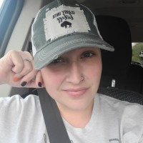
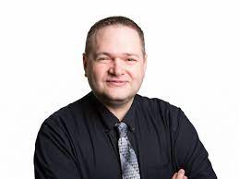
Ashley is currently a Face2Face Program Specialist with Kids Escaping Drugs. In her current position she provides both education as well as community outreach to local youth by means of school presentations and early interventions for at risk youth. She spent 7 years prior to coming to KED as both a staff trainer and direct support professional for a non-profit agency that serves developmentally and intellectually disabled adults as well as many years as both a volunteer and paid EMT. Ashley is a 2008 graduate of Frontier High School and has remained in the area to raise her family. Ashley began working at Kids Escaping Drugs in January of 2022 and has enjoyed every day. Interacting with the youth both on campus and in the community is enjoyable and fulfilling. She hopes her passion and enthusiasm comes across in the presentations she does and the early interventions and reaches the many different lives she has the opportunity to encounter

Faces of Addiction - Perspectives of an Addict
Presented by – Alex Neutz
Alex will share his personal struggle with mental health and addiction. This is an excellent opportunity for attendees to hear how these issues impact individuals. Alex will discuss in depth how his struggles impacted his life including sports, family, relationships, and more. This presentation will also feature a candid Q&A allowing attendees to collect important and vital information to take back to their communities. This testimonial/workshop is proof that addiction can truly happen to anyone.
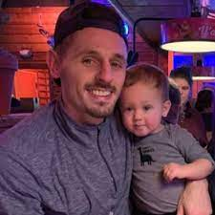
About Alex Neutz
Born and raised in Grand Island, New York. Was a star athlete and student in high school earning him and division one scholarship to the University at Buffalo. Excelling on and off the field, Alex broke multiple records for the UB football team while maintaining a high GPA. However, injuries introduced him to opiates and led him down a path of addiction and destruction that no person can really prepare for. Sober now for 6 years Alex is a father and a teacher, spending time educating others on addiction and mental health in hopes others can avoid going through the struggles he endured

Procedural Justice
Presented by – Sean McCarthy

Procedural Justice is a tactic that is structured around four central principles: Voice, Neutrality, Respect, and Trustworthiness. These four principles build upon one another to guide police and community interactions. Through the continued practice of Procedural Justice officers experience less stress, crime is reduced, civilian complaints are reduced, and the community is given a voice resulting in greater cooperation with the police.

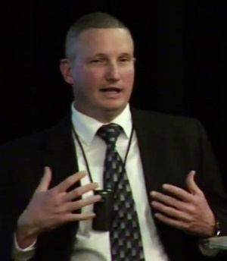
About Lt. Sean McCarthy
Sean McCarthy started his police career in 1994 with the Village of Pawling Police Department. In 2000, he was hired by the City of Poughkeepsie Police Department.

After starting in patrol, Sean worked most of his career in the community policing and narcotics units before being promoted to Sergeant. After two years as a patrol sergeant, he was promoted to Administrative Sergeant. As the Administrative Sergeant, he was in charge of the 911 center, all reports and records, and all civilian staff.

Sean currently holds the rank of Lieutenant and is the 12x8 Watch Commander as well as the Commanding Officer of the City of Poughkeepsie’s Hostage Negotiation Unit. Sean currently teaches several topics in the police academy and supervisor school for both the Dutchess County Academy and the Ulster County Law Enforcement Training Group. Sean is one of six New York State Master Instructors in Procedural Justice and Implicit Bias. As such, he travels the state teaching other trainers on these topics. In addition, he has helped develop and institute a procedural justice program for the City of Poughkeepsie Police Department. Sean holds a bachelor’s degree in Criminals Justice from Empire College. He is currently enrolled in the Masters of Business Program at Marist College.

Sean is the owner of Future Policing Consultants. He is also the president and a founding member of the Police Emerald Society of the Hudson Valley and a former board member of several other police and youth organizations

L.E.A.P., Law Enforcement Assistance Program
Presented by Jim Banish, President NYS LEAP
You ARE NOT ALONE, We have been there; we know the way out
Being a first responder brings with it a lot of trauma and toxic stress, as a result of being “helplers” and the culture of the job. First responders resist seeking help for themselves. We are here to help; you, and your family

PTSD/Post Critical Incident
Presented by James Banish
This training seminar is designed to assist first responders that have been involved in on-duty critical incidents, cumulative career stress, or traumatic life events unrelated to their law enforcement career, and have had an adverse effect in their everyday life as a result. This is a peer-based program, where peer-to-peer assistance will be accompanied by clinical staff, to assist the attendees in finding healthy ways to cope with stress and manage PTSD.

About James Banish
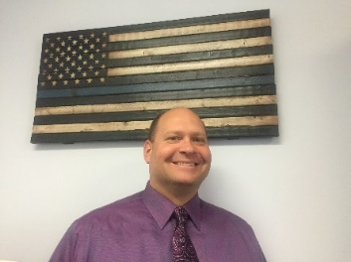
Jim has served 20 years as a patrol officer, working in many different roles along the way. In 2008 his life and career took on a whole new path after his brother Lt. Joseph Banish NYSP took his life on April 1st. For several years after Jim's life became very tumultuous and he was suffering from deep depression directly related to his job and the traumas that he had experienced over his career. When Jim was beyond the point where he needed to get help, he discovered that it wasn't as readily available as one would think. Fortunately for Jim he was able to get the help he needed but discovered that this was a problem within Law Enforcement Nationwide. He decided to take action by identifying resources in his local area first and also reaching out to fellow officers who Jim knew were struggling as he was, and then directing them to the resources that he had discovered. Over the past 7 years Jim has expanded by helping other officers throughout the country and assisting the New York State Division of Criminal Justice Services with educating others and assisting in teaching a class called TRAUMA all over NYS. When requested, Jim even travels to other parts of the Country to share this training with Law Enforcement Agencies. Jim is currently a Patrol Officer and the Peer Support Coordinator with the Warren County Sheriffs Office. His main goal is to continue to help other officers in need by assisting them through their trauma and also by providing the education to all Law Enforcement so that signs and symptoms do not go unnoticed and that we break the stigma which comes with getting help. NYLEAP was started for that exact reason and will bring that education and assistance to Law Enforcement agencies all over New York. NYLEAP is working in conjunction with other States and will continue to bring assistance and awareness in an effort to stop Law Enforcement Suicides and provide a better quality of life to Law Enforcement families.

Investigating Missing and Abducted Children Cases
Presented by David Fallon, Ret. FBI

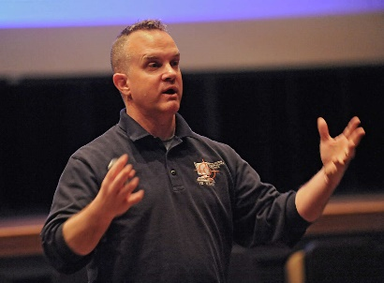
About David Fallon

Less is More & Minimal Facts
Presented by John Kelly and Jami Bolton

Created by the New York State Children’s Alliance, Inc., the Less is More training highlights the integral role a Mandated Reporter has in a child abuse investigation process by understanding what is needed to make a call to the State Central Registry (SCR), and what happens after the call is made. Presented in collaboration with the Minimal Facts training, participants will understand what to do when in a situation of a disclosure and that the goal is to gather minimal facts in a manner that will not jeopardize the integrity of the forensic interview and investigation, or cause further trauma to the child. This training is to help Mandated Reporters feel confident about what to do when they suspect child abuse, and reassure them of the importance of their role when it comes to protecting children.
About John Kelly and Jami Bolton
John Kelly is the Statewide MDT Director for the New York State Children’s Alliance which is a non profit that provides training and technical assistance to 46 Child Advocacy Centers across New York State. Before joining NYSCA John worked 23 years for Saratoga Springs Police Dept and retired as an SRO/Investigator. Upon retiring he worked 3 years with the National Center for Missing & Exploited Children helping to open the NY Capital Region Office of NCMEC co-located at the CAC in Saratoga Springs. John also held the position of Law Enforcement Coordinator at the CAC in Saratoga Springs performing such duties as Case Review, Peer Review and child forensic interviews.
John is a trained forensic interviewer and regularly conducts peer review for MDT members throughout the state. He is honored to be working with so many MDT members who dedicate their careers to helping children and families across our state

Jami Bolton is the Director of Training and Development for the New York State Children’s Alliance, which she has been with for 4 years. In her role she coordinates and provides training to Child Advocacy Centers in NY by identifying trends and CAC needs. Previously she worked for the Child Advocacy Center in Onondaga County for almost seven years doing work as a Victim Advocate before moving into Prevention Education. She has extensive experience in training both children and adults in topics related to child abuse. She has a dual degree in Psychology and Child & Family Studies from Syracuse University.

Supporting Teens at Risk for Suicide (STARS)
Presented by the NYS Office of Mental Health

STARS utilizes a trauma-informed response to youth and their caregivers when risk for suicide is identified. Suicidal thinking and behavior are an unfortunate reality for the youth we serve. Within and across youth serving organizations, practices vary widely in responding to a child or teen who is exhibiting warning signs that they may be at risk for suicide. This skills-based and practice-oriented workshop is designed to prepare the workforce at youth serving organizations to respond effectively to assist teens who may be at risk for suicide. Participants who attend the entire workshop will learn how to:

- Recognize warning signs of suicide
- Provide a brief assessment utilizing the CSSRS brief screener
- Refer to an appropriate level of care
- Develop a safety plan
- Put ongoing supports in place
- Identifying the importance of shared responsibility

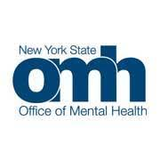
About

Active Shooter and Post Incident
Presented by – Chief Thomas Ruehle, Sand Point PD

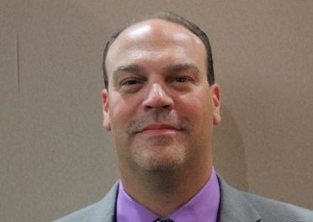
About Chief Thomas Ruehle
Tom Ruehle is the Chief of Police of Sands Point Police Department in Nassau County on long island. Tom became a police officer in 1997, being promoted to Sgt in 2008, Lt, in 2015, and Chief of Police in 2019. Chief Ruehle has been involved in juvenile justice for most of his career and is the immediate past present of the State of New York Police Juvenile Officers Association. Tom is certified as an SRO, Juvenile Officer, DCJS Certified instructcor and firearms instructor and Secretary of the Nassau County Police Chiefs Association.

TEAM, Together Everyone Achieves More
Presented by – Devine Leacock, Cattaragus Sheriffs Office

T.E.A.M acronym stands for Together, Everyone Achieves More. Unfortunately with the negative press on L.E. in the news, the concept of TEAM provides ideas and concepts to help strengthen the relationships with the community and L.E

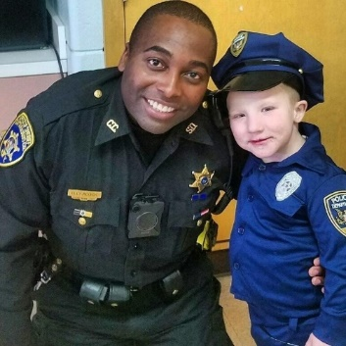
About Devine Leacock
Devine Leacock is a 15 year veteran with the Cattaraugus County Sheriff's office. Of the 15 years of service, Deputy Leacock has a total of 10 years as a SRO (school resource officer). Deputy Leacock originally from Rochester NY. Made is way to the southern tier after attending Alfred State College and Jamestown Community. Upon graduating , he returned to Rochester and worked as a security guard at Marketplace Mall. Working alongside some great officers, he then decided to pursue my dream and get into law enforcement, where he has excelled as an officer. He sits on his local school board and is currently the President of the State of New York Police Juvenile Officers Assocation.

Amber Alert Training
Presented by NYSSE

